# Overview

This document contains the necessary information to build the Open Playback Recorder.

Contents

Overview 1

Maker Checklist 3

Maker To Do List 3

Items to Give to User 3

Tool List 4

Customization Guide 4

3D Printing Guide 5

3D Printing Summary 5

3D Printing Settings 5

Post-Processing 5

Examples of Quality Prints 6

Custom Printed Circuit Board (PCB) Guide 10

Ordering the Custom PCB 10

Assembly Guide 12

Required Components 12

Required Tools 16

Required Personal Protective Equipment (PPE) 16

Bottom Enclosure 17

Step 1: Solder the battery leads 17

Step 2: Solder the capacitor 17

Step 3: Solder the power switch 18

Step 4: Solder the MicroSD card reader 18

Step 5: Solder the push buttons 19

Step 6: Solder the 3.5mm jacks 20

Step 7: Solder in the microcontroller headers 20

Step 8: Solder in the ribbon cable header 21

Step 9: Add the T-Nut to the bottom enclosure 23

Step 10: Add buttons to the enclosure. 24

Step 11: Screw PCB into the bottom enclosure 25

Step 12: Connect the battery 26

Step 13: Program the microcontroller **Error! Bookmark not defined.**

Bottom Enclosure Done 26

Top Enclosure 27

Step 1: Solder in the resistors 27

Step 2: Solder in the Level LEDs 27

Step 3: Solder in the Play and Rec LEDs 28

Step 4: Solder the amplifier terminal and male headers 28

Step 5: Solder the amplifier female headers 29

Step 6: Solder the ribbon cable header onto the PCB 29

Step 7: Solder the microphone to the PCB 30

Step 8: Solder the potentiometer into the PCB 30

Step 9: Slide the PCB into the top enclosure 31

Step 10: Attach the volume knob 32

Step 11: Connect the speaker 33

Step 12: Connect the speaker 34

Step 13: Connect the ribbon cable 34

Step 14: Close the enclosure 35

Top Enclosure Done 35

Programming 36

Step 1: Setup Arduino IDE on Computer 36

Step 2: Open the Library Manager 36

Step 3: Search the TMRpcm library 37

Step 4: Enable Recording 37

Step 5: Open the Preferences 38

Step 6: Add the Board URL 39

Step 7: Add the Seeeduino Nano Board 40

Step 8: Connect the Open Playback Recorder to the Computer 41

Step 9: Program the Microcontroller 41

Testing 41

Power on the device with battery power 41

Record multiple messages on one level 41

Adjust the volume 42

Record a message on each level 42

Delete the multiple messages and record one message 42

Power the device with USB power 42

Troubleshooting 42

Both Play and Record LEDs flashing when device is powered on 42

# Maker Checklist

This list provides an overview of the steps required to build and deliver the device.

## Maker To Do List

* Read through the Assembly Guide to become familiar with required components, tools, supplies, and safety gear and overall assembly steps.
* Talk to User about customization options (e.g., color, any special requests, etc.)
* Order hardware components
* Gather tools, supplies, and safety equipment.
* Assemble the device
* Test device
* Print “User Guide”

## Items to Give to User

* Assembled, tested device
* “User Guide”

# Tool List

* 3D printer
* Soldering iron and solder
* Small flathead screwdriver
* Small Phillips screwdriver
* ¼-20 Bolt

# Customization Guide

The device can be printed in the user’s desired colour.

The text on the enclosure can be printed in a separate colour from the enclosure to increase contrast

The base and lid can be printed in separate colours for a two tone effect

# 3D Printing Guide

## 3D Printing Summary

|  |  |
| --- | --- |
| **Metrics** | **Single Unit** |
| Total Print Time (min) | 194 (3h14) |
| Total Number of Components | 9 |
| Typical Total Mass (g) | 90 |
| Typical Number of Print Setups | 2 |

## 3D Printing Settings

|  |  |  |  |  |  |  |  |
| --- | --- | --- | --- | --- | --- | --- | --- |
| **Print File Name** | **Qty** | **Total Print Time (hr:min)** | **Mass (g)** | **Infill (%)** | **Support(Y/N)** | **Layer Height/ Nozzle Diameter(mm)** | **Notes** |
| Base.stl | 1 | 1:10 | 40 | 20 | N | 0.2/0.4 |  |
| Battey Cover.stl | 1 | 0:16 | 5 | 20 | N | 0.2/0.4 |  |
| 3 LED Spacer.stl | 1 | 0:06 | 1 | 20 | N | 0.2/0.4 |  |
| 2 LED Spacer.stl | 1 | 0:05 | 1 | 20 | N | 0.2/0.4 |  |
| Level Button.stl | 1 | 0:03 | 1 | 20 | N | 0.2/0.4 |  |
| Lid.stl | 1 | 1:19 | 39 | 20 | N | 0.2/0.4 |  |
| Play Button.stl | 1 | 0:03 | 1 | 20 | N | 0.2/0.4 |  |
| Record Button.stl | 1 | 0:03 | 1 | 20 | N | 0.2/0.4 |  |
| Volume Knob.stl | 1 | 0:09 | 1 | 20 | N | 0.2/0.4 |  |

## Post-Processing

* Use a hobby knife to remove any burrs or bumps

## Examples of Quality Prints

**Photo of Base.stl**

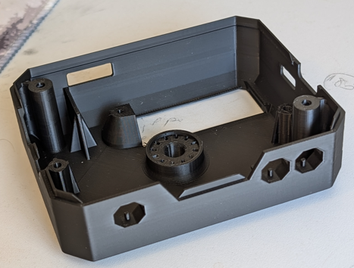 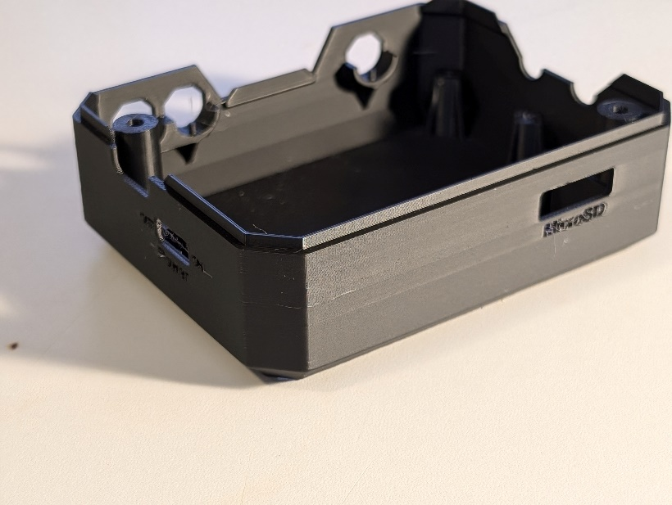

**Photo of Battery Cover.stl**

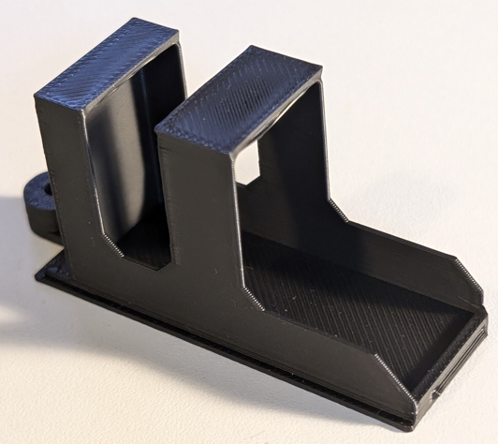 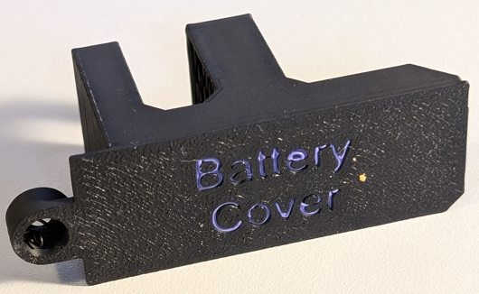

**Photo of Lid.stl**

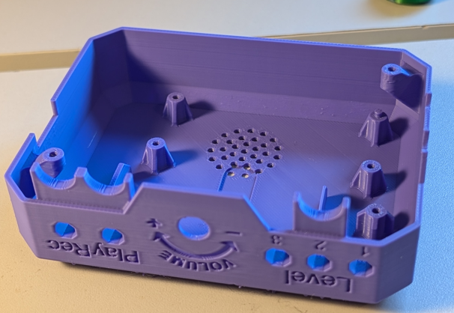

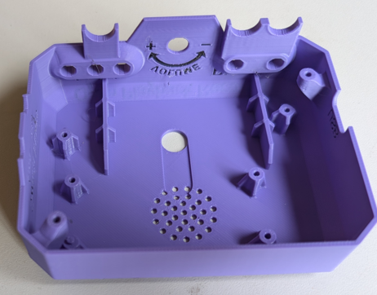

**]Photo of Level Button.stl**

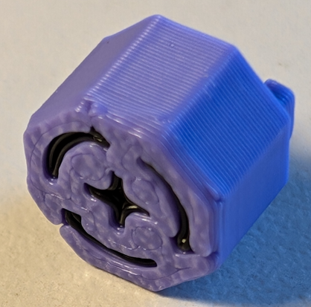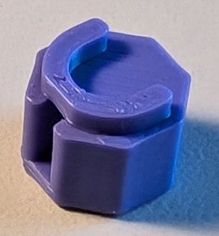

**Photo of Play Button.stl**

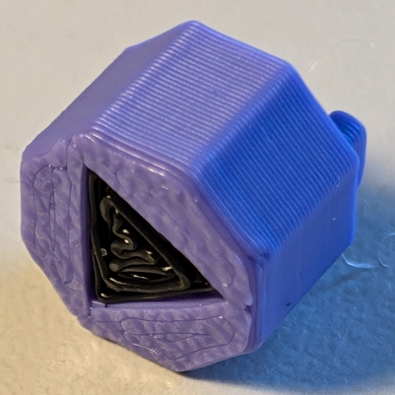 

**Photo of Record Button.stl**

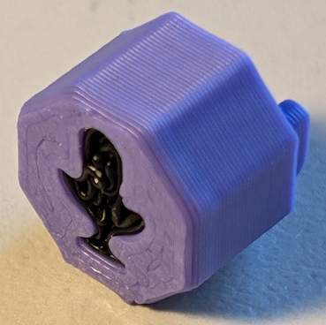 

**Photo of Volume Knob.stl**

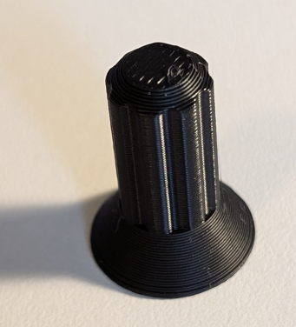

**Photo of 3 LED Spacer.stl**

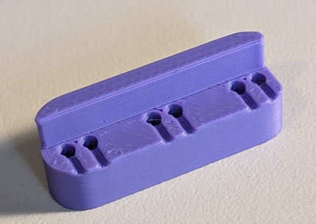

**Photo of 2 LED Spacer.stl**

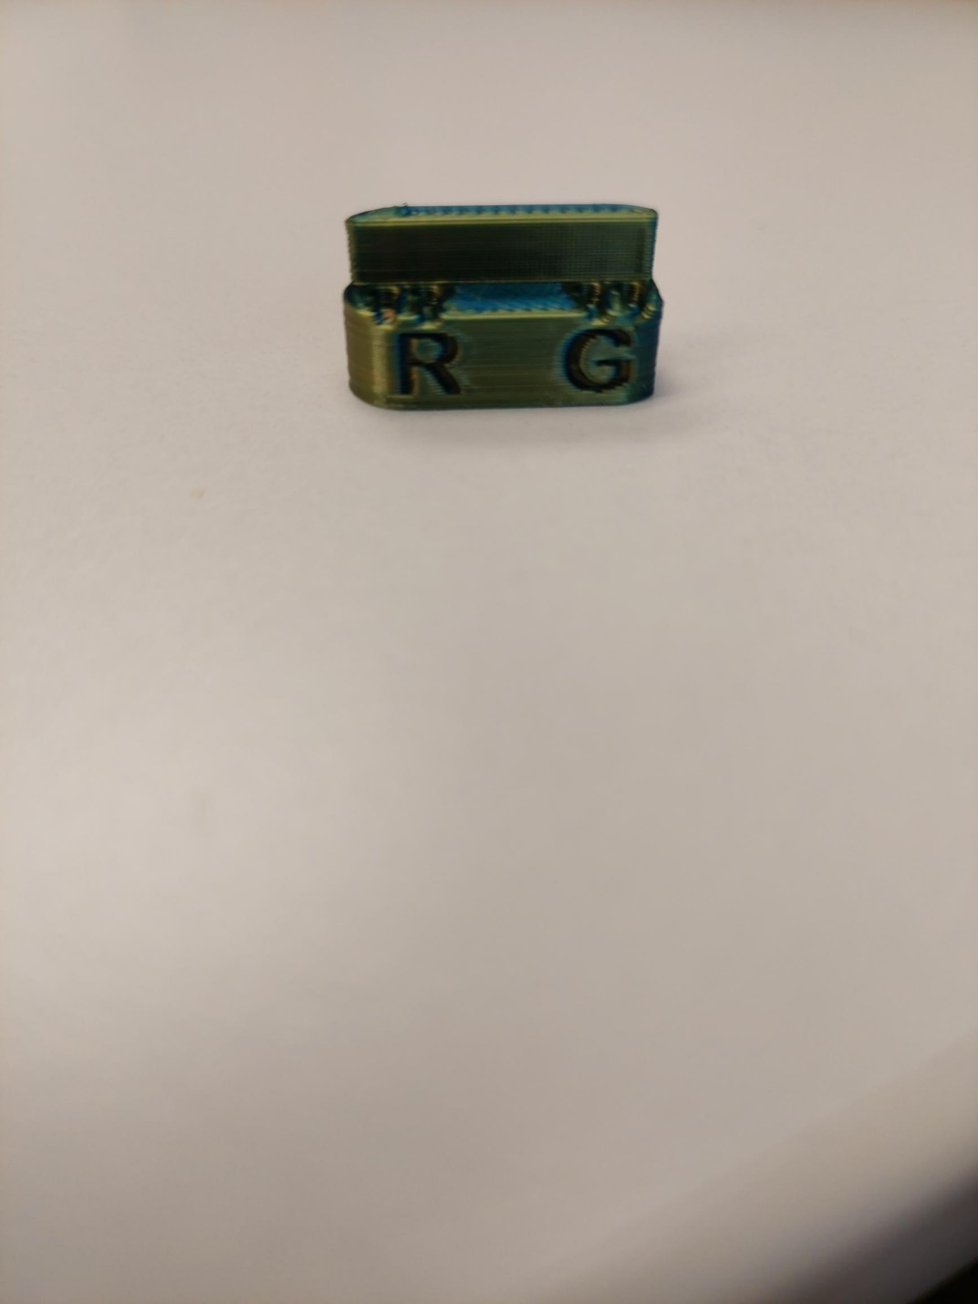

# Custom Printed Circuit Board (PCB) Guide

The Open Playback Recorder uses 2 custom circuit board/boards.

The Custom PCB can be ordered from one of a variety of PCB Manufacturers. Typically, the minimum quantity for a custom PCB is five. Shipping options vary significantly in cost and shipping time. Plan on at least a week from the time of order to the PCBs arrival.

## Ordering the Custom PCB

1. Select a PCB Fabrication Company
   1. [JLPCB](https://jlcpcb.com/)
   2. [PCBWay](https://www.pcbway.com/)
   3. [OSH Park](https://oshpark.com/)
   4. [Seeed Fusion PCB](https://www.seeedstudio.com/fusion_pcb.html)
2. Create an account or use a guest login.
3. Upload both the Gerber Files (e.g., Open_Playback_Recorder_Top_2024-06-26.zip, Open_Playback_Recorder_Bottom_2024-06-26.zip).
4. Select the fabrication options for each PCB:
   1. PCB Layers: 2 Layers
   2. PCB Quantity: 1
   3. PCB Thickness: 1.6 mm
   4. Surface Finish: HASL with lead
   5. PCB Color: Choose what you like. Note that certain colours may impact build time and cost.
   6. The default settings for the other settings should work.
5. Select shipping option.
   1. Shipping options and costs vary significantly. Select the best option based on your budget and timing.
6. Submit the order.

# Assembly Guide

## Required Components

|  |  |  |  |  |  |  |  |  |
| --- | --- | --- | --- | --- | --- | --- | --- | --- |
| **01** | **Bottom PCB** | **QTY: 1** | **02** | **Battery Clip** | **QTY: 1** | **03** | **0.1 uF Capacitor** | **QTY: 1** |
| Bottom PCB | | | Battery Clip | | | Capacitor | | |
| **04** | **Slide Switch** | **QTY: 1** | **05** | **Micro SD Card Reader** | **QTY: 1** | **06** | **Press Button** | **QTY: 3** |
| Slide switch | | | MicroSD card reader | | | Press button | | |
| **07** | **Mono Cable Jack** | **QTY: 2** | **08** | **15 Pin Female Header** | **QTY: 2** | **09** | **Seeeduino Nano** | **QTY: 1** |
| Mono cable jack | | | 15 pin female header | | | Seeeduino Nano | | |

|  |  |  |  |  |  |  |  |  |
| --- | --- | --- | --- | --- | --- | --- | --- | --- |
| **10** | **Ribbon Cable Header** | **QTY: 2** | **11** | **#4 Sheet Metal Screw** | **QTY: 11** | **12** | **9V Battery** | **QTY: 1** |
| Ribbon cable header | | | #4 sheet metal screw | | | 9V Battery | | |
| **13** | **Level Button** | **QTY: 1** | **14** | **Play Button** | **QTY: 1** | **15** | **Rec Button** | **QTY: 1** |
| The octagonal level button | | | The play octagonal button | | | The octagonal record button | | |
| **16** | **Base** | **QTY: 1** | **17** | **Battery Cover** | **QTY: 1** | **18** | **Micro SD Card** | **QTY: 1** |
| Base printed in black | | | Battery cover printed in black | | | Micro SD card printed in black | | |

|  |  |  |  |  |  |  |  |  |
| --- | --- | --- | --- | --- | --- | --- | --- | --- |
| **19** | **2 kOhm Resistor** | **QTY: 5** | **20** | **3 LED Spacer** | **QTY: 1** | **21** | **Blue LED** | **QTY: 3** |
| blue 2 kOhm resistor | | | 3 LED spacer printed in purple | | | Blue LED | | |
| **22** | **2 LED Spacer** | **QTY: 1** | **23** | **Red LED** | **QTY: 1** | **24** | **Green LED** | **QTY: 1** |
| A photo of the 2 LED spacer with R and G labels on it, printed in dark green | | | Red LED | | | Green LED | | |
| **25** | **PAM8302** | **QTY: 1** | **26** | **5 Pin Female Header** | **QTY: 1** | **27** | **MAX9814** | **QTY: 1** |
| Audio Amplifier | | | 5 pin female header | | | Max9814 microphone | | |

|  |  |  |  |  |  |  |  |  |  |  |
| --- | --- | --- | --- | --- | --- | --- | --- | --- | --- | --- |
| **28** | | **10 kOhm Logarithmic Potentiometer** | | **QTY: 1** | **29** | **Lid** | **QTY: 1** | **30** | **Volume Knob** | **QTY: 1** |
| Silver potentiometer on its side | | | | | Lid printed in purple with the text printed in black | | | Volume knob printed in black | | |
| **31** | | **4 Ohm 3W Speaker** | | **QTY: 1** | **32** | **Ribbon Cable** | **QTY: 1** | **33** | **Top PCB** | **QTY: 1** |
| Speaker sitting on its coiled cable | | | | | Grey ribbon cable folded in half | | | Top PCB | | |
| **34** | **¼-20 T-Nut** | | **QTY: 1** | |  | | |  | | |
| A close up of the T-nut | | | | |  | | |  | | |

## Required Tools

* Soldering Iron
* Solder
* Small flathead screwdriver
* Phillips Screwdriver
* ¼-20 Bolt

## Required Personal Protective Equipment (PPE)

* Safety glasses
* Solder fume extractor (optional)

## Bottom Enclosure

### Step 1: Solder the battery leads

Take the battery clip (02) and solder it to the bottom PCB (01) on the 9V footprint with the black lead connected to the -, and the red lead connected to the +.

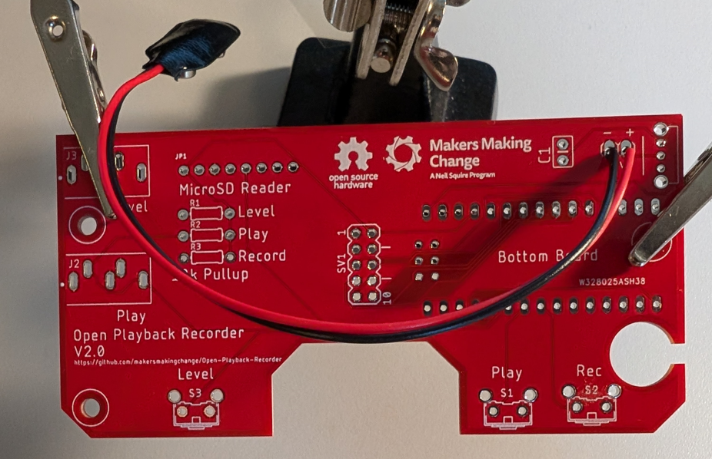

### Step 2: Solder the capacitor

Take the 0.1 uF capacitor (03) and solder it to the PCB on the C1 footprint. Trim the leads on the other side of the board.

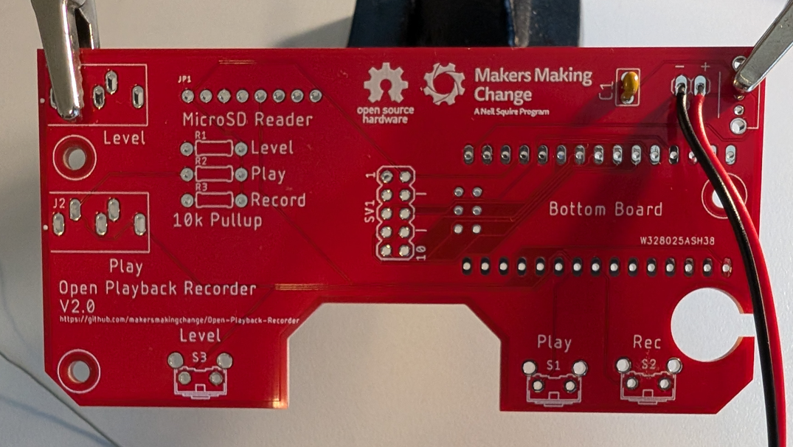

### Step 3: Solder the power switch

Take the power switch (04) and solder it to the PCB beside the battery clip, with the switch facing the side of the PCB

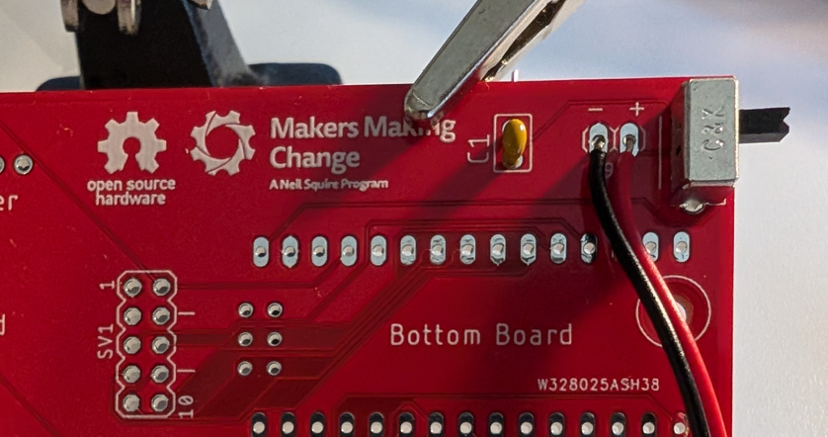

### Step 4: Solder the headers to the MicroSD card reader

Solder the male header that came with the microSD card reader (05) to the reader with the short pins of the header in the microSD card reader and the long side of the pins facing away from the reader as shown in the below picture. Insert the microSD card (18) into the reader. You may need to trim one pin from the header that comes with the reader to get it to the correct number of pins.

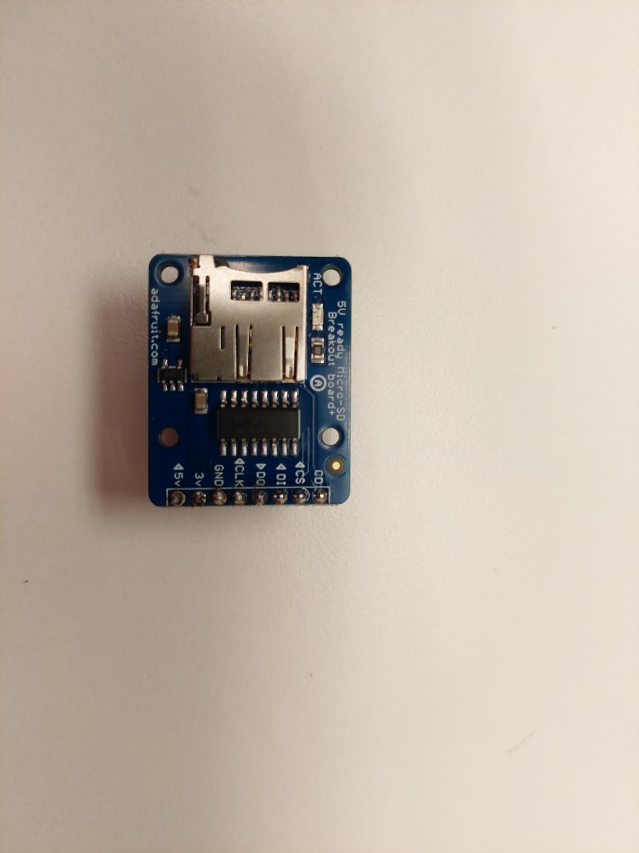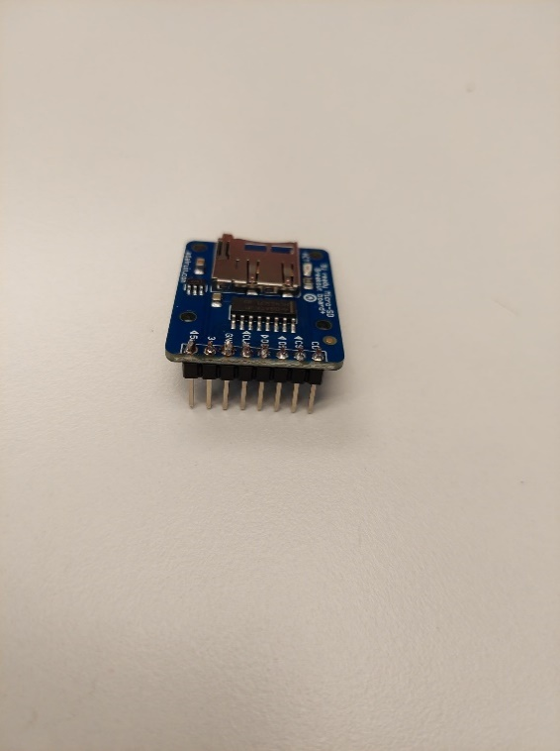

### Step 5: Solder the MicroSd card reader to the PCB

Solder the MicroSD card reader to the PCB with the SD card socket facing away from the PCB, as seen in the below photo. When soldering the reader, ensure that the board is parallel to the PCB.

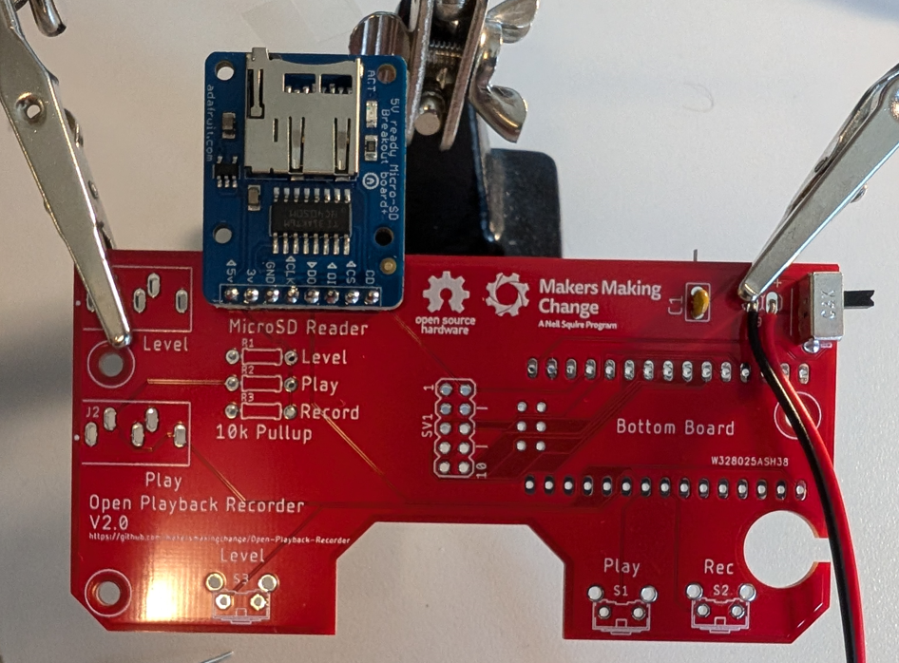

### Step 5: Solder the push buttons

Take the three push buttons (06) and solder them into the Level, Play, and Rec footprints on the PCB, with the button facing the edge of the board.

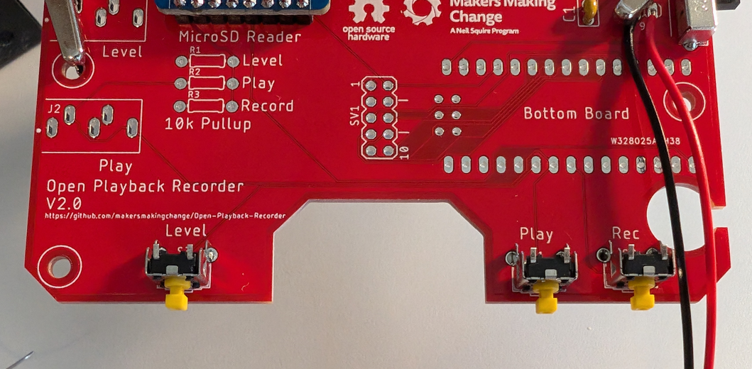

### Step 6: Solder the 3.5mm jacks

Solder both of the 3.5mm jacks (07) to the PCB on the Level and Play footprints

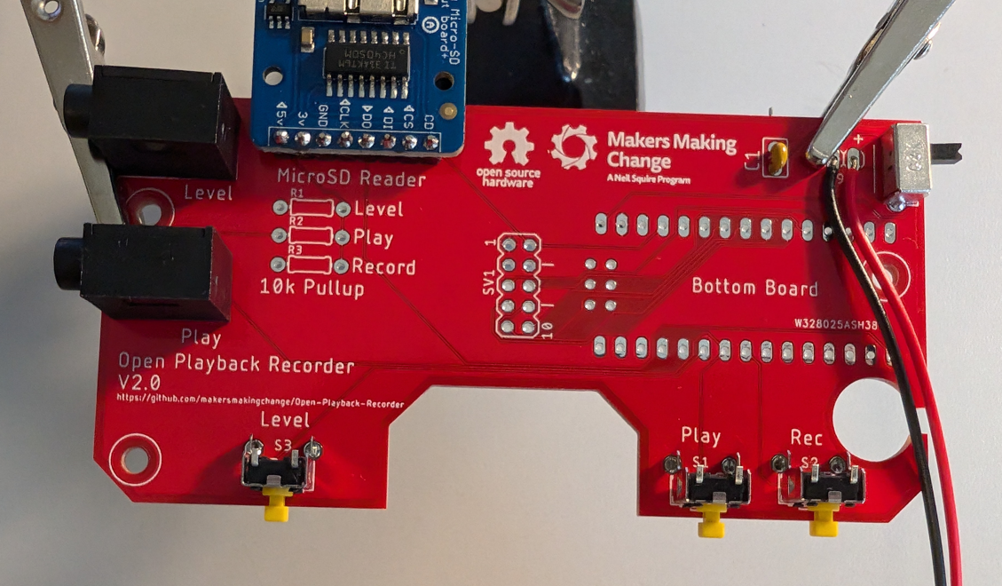

### Step 7:Using your fingers ect....

Take both of the 15 pin headers (08) and press them on to the pins of the microcontroller(09) .

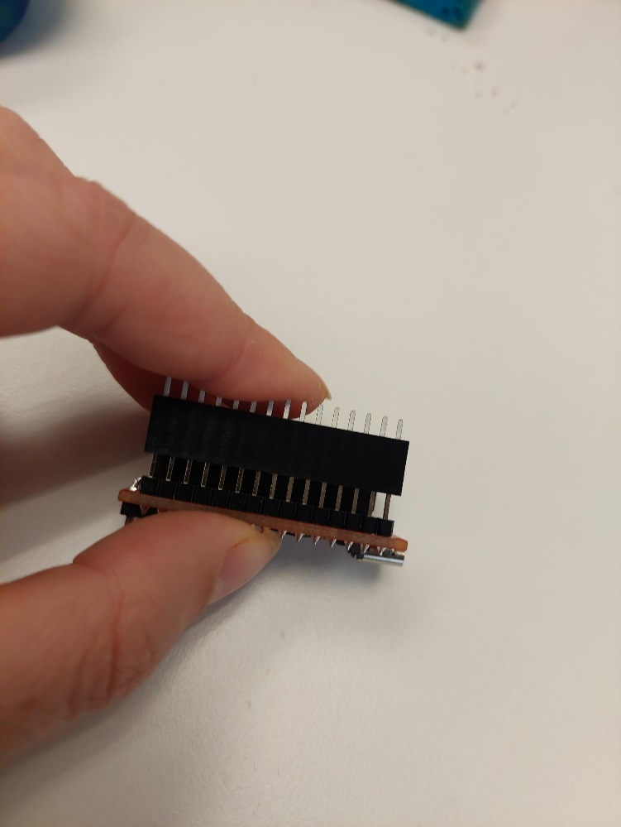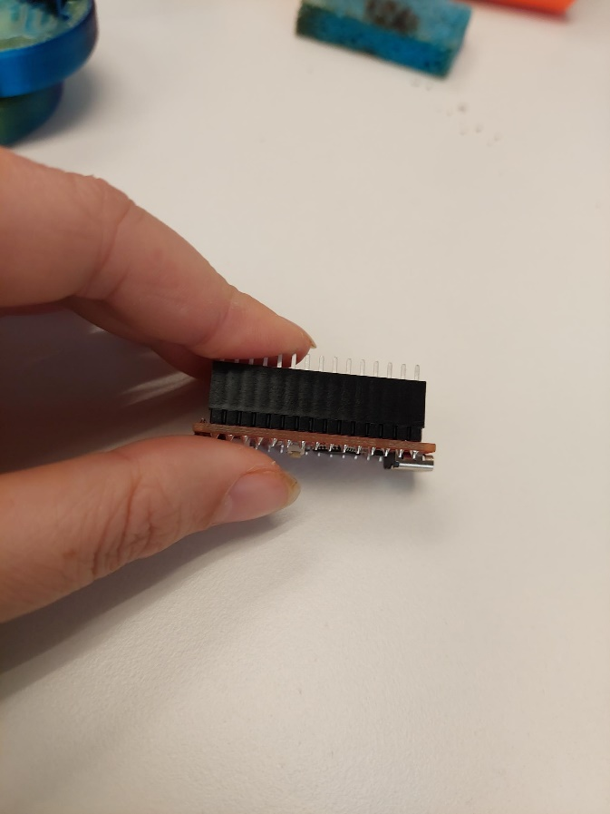

### Step 8: Solder them in place and remove the microcontroller.

Take the microcontroller with the pins attached and place it into the matching slots on the PCB. Make sure that the USB C port on the microcontroller is facing the edge of the PCB. Solder the header pins to the PCB.

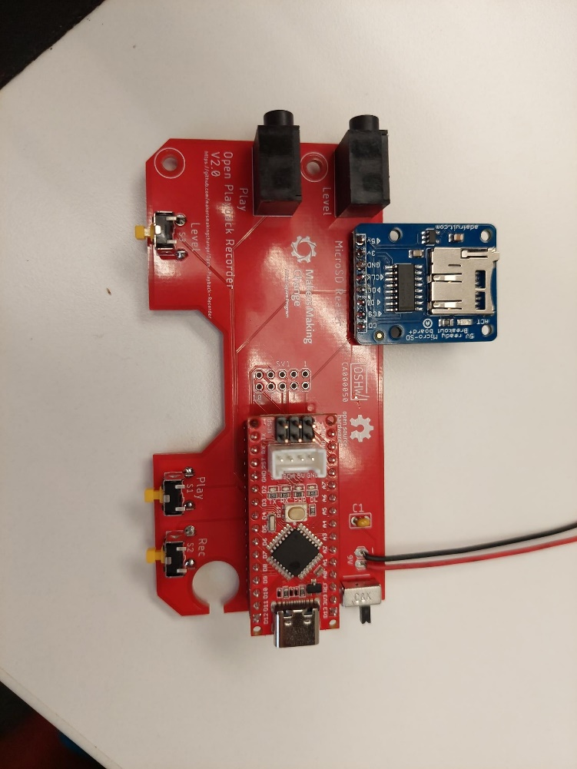

### Step 8: Solder in the ribbon cable header

Solder the ribbon cable header (10) to the SV1 footprint on the PCB. Align the gap on the header with the two lines on the footprint facing the microcontroller.

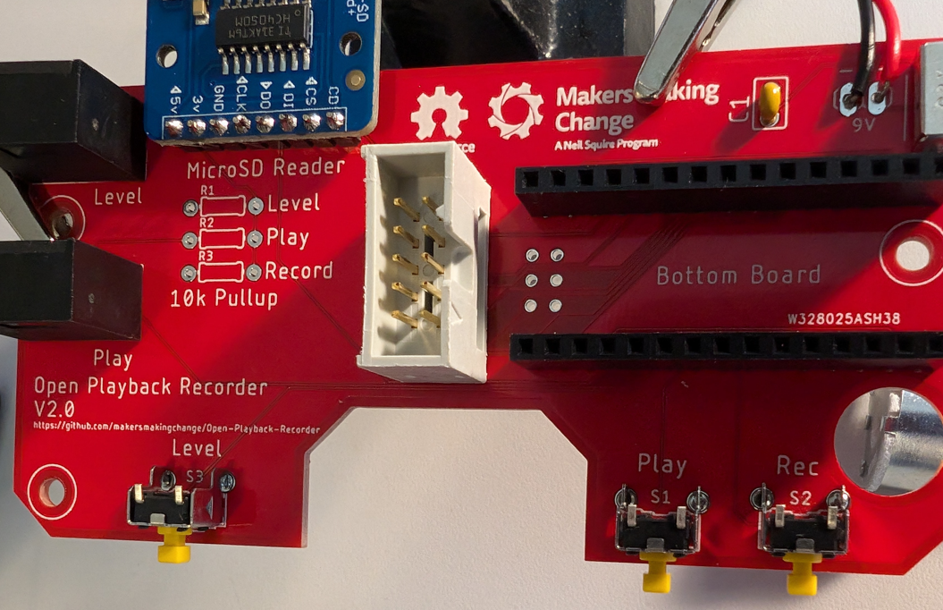

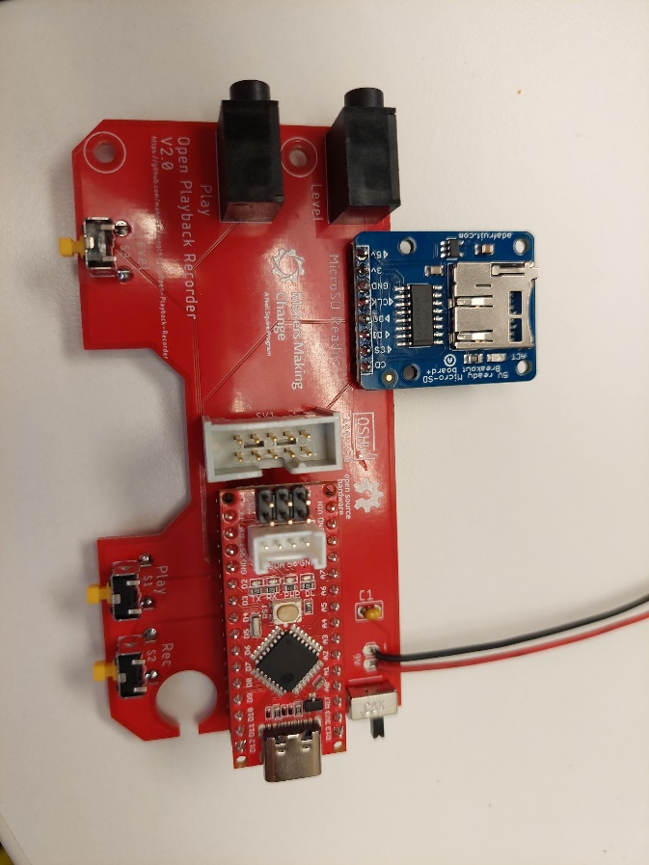

### Step 9: Add the T-Nut to the bottom enclosure

Take the T-Nut (34) and the base enclosure (16), press the T-nut into the round raised section in the middle of the base. Using a ¼-20 bolt, tighten the T-Nut in place. Remove the bolt.

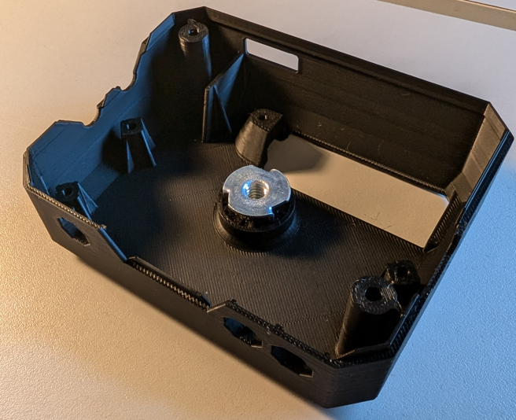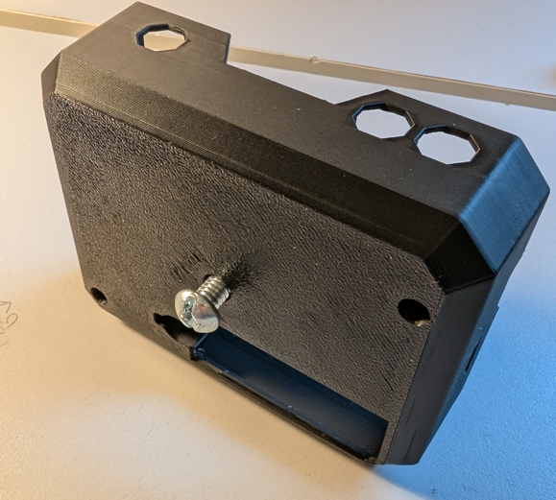

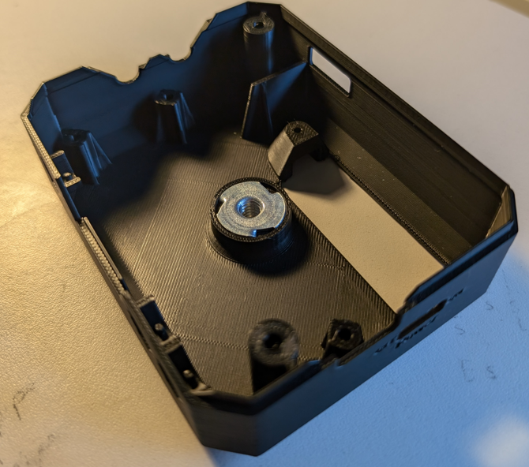

### Step 10: Add buttons to the enclosure.

Take the Play button print (14), the Rec button (15), and the Level button (13) and insert them into the base enclosure (16). Align the slot on the bottom of each button with the peg on the button track, and insert the button from the inside of the enclosure and slide it out.

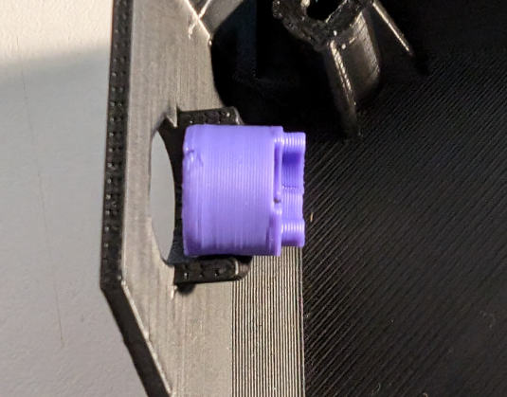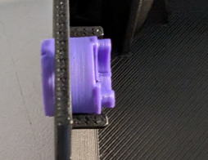

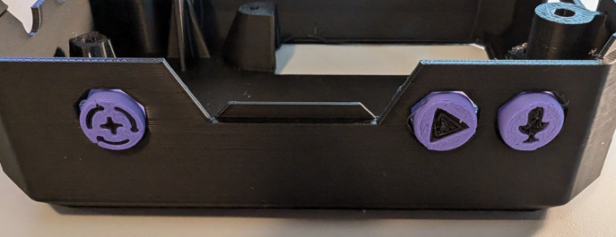

### Step 11: Screw PCB into the bottom enclosure

Place the PCB into the enclosure so that the cutout on the board lines up with the screw boss in the enclosure and the buttons in the enclosure capture the buttons in the enclosure. Use three of the screws (11) to secure the PCB to the enclosure.

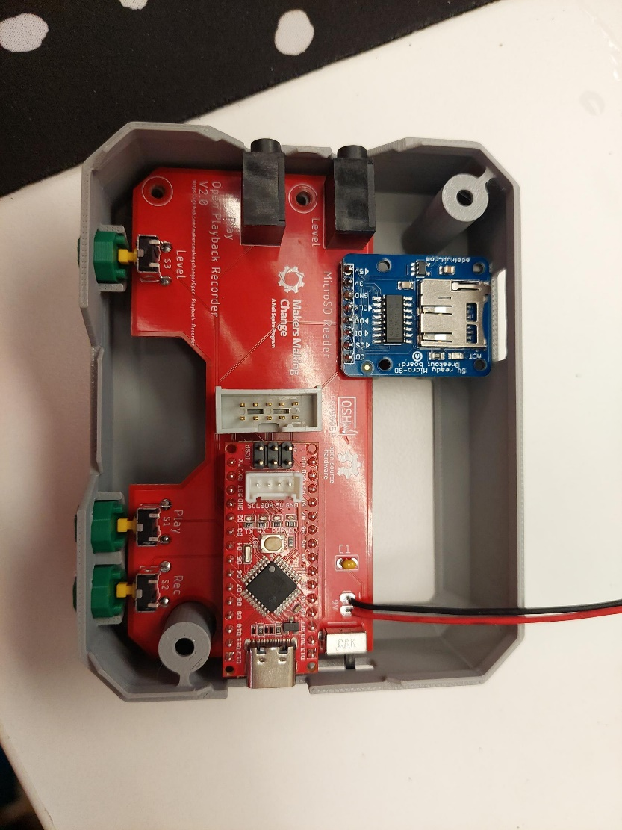

### Step 12: Connect the battery

Take the battery (12) and slide it into the battery cover (17) with the smaller terminal towards the bottom, as shown in the below photo. Pass the battery clip from the board out the battery cutout in the enclosure, and clip it to the battery. Insert the battery assembly into the enclosure and use a screw (11) to secure it in place. Slide the power switch on the enclosure to OFF.

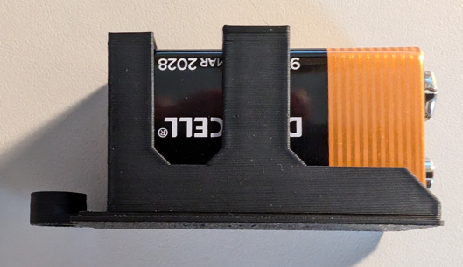

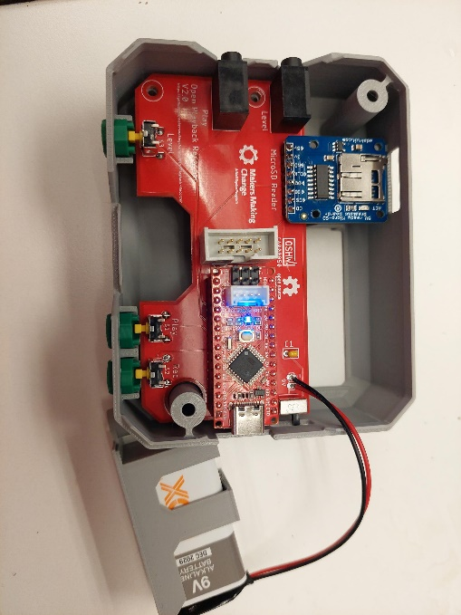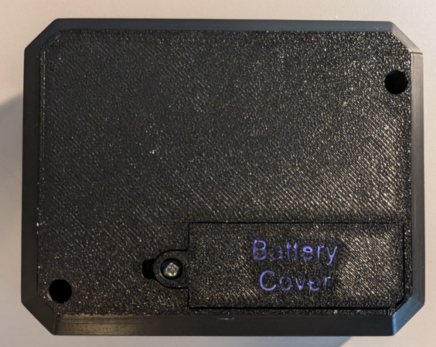

### Bottom Enclosure Done

## Top Enclosure

### Step 1: Solder in the resistors

Take the resistors (19) and solder them into the R1, R2, R3, R4, and R5 footprints onto the top PCB (33). Trim the leads flush on the other side.

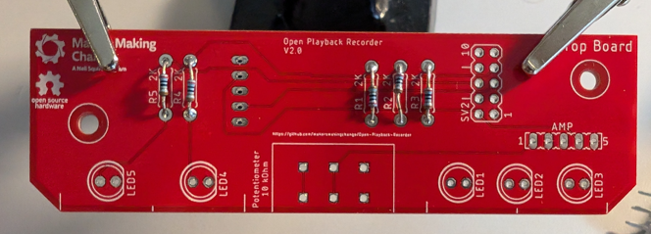

### Step 2: Solder in the Level LEDs

Take the three blue LEDs (21) and the 3 LED spacer (20). With the flats of the LEDs facing the flat side of the spacer (circled), insert them into the spacer so that they are resting on the ledge of the spacer. When looking at the spacer from the front with the ledge in the back (Photo 1 on the left), the short leg of the LEDs should be on the right. Pass the legs of the LEDs through the footprints for LED1 LED2 and LED3 on the PCB so that the flats of the LEDs line up with the flats on the footprints. Solder the LEDs in place, then use the spacer to bend them 90 degrees so they face the side of the PCB. Trim the leads flush with the PCB.

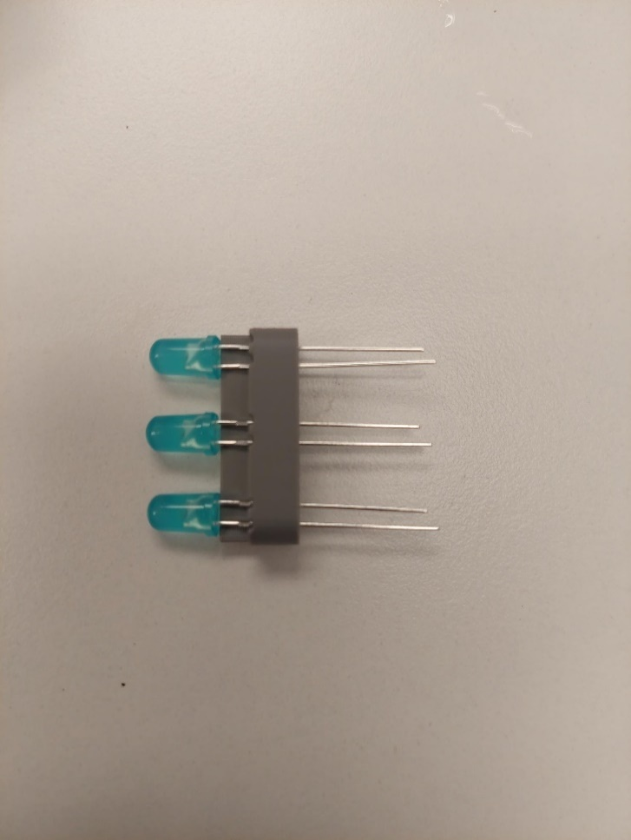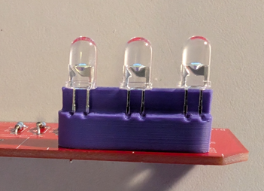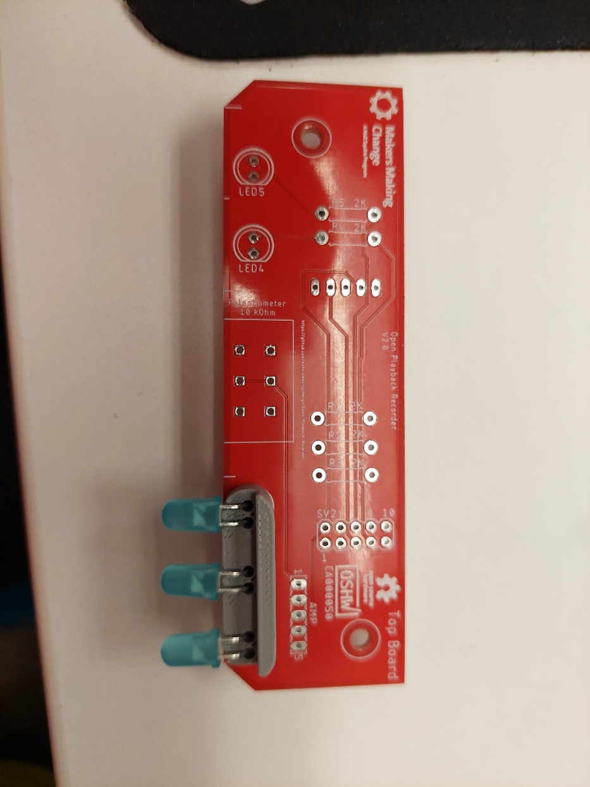

### Step 3: Solder in the Play and Rec LEDs

Take the red Rec LED (23), the green Play LED (24) and the 2 LED spacer (22). With the flats of the LEDs facing the flat side of the spacer (circled), insert them into the spacer so that they are resting on the ledge of the spacer. With the R+G label facing the front, the green LED should be inserted over the G, and the red LED should be inserted over the R. The short leg of the LEDs should be facing the right. Pass the legs of the LEDs through the footprints for LED4 and LED5 on the PCB so that the flats of the LEDs line up with the flats on the footprints. Solder the LEDs in place, then use the spacer to bend them 90 degrees so they face the side of the PCB. Trim the headers on the bottom of the PCB.

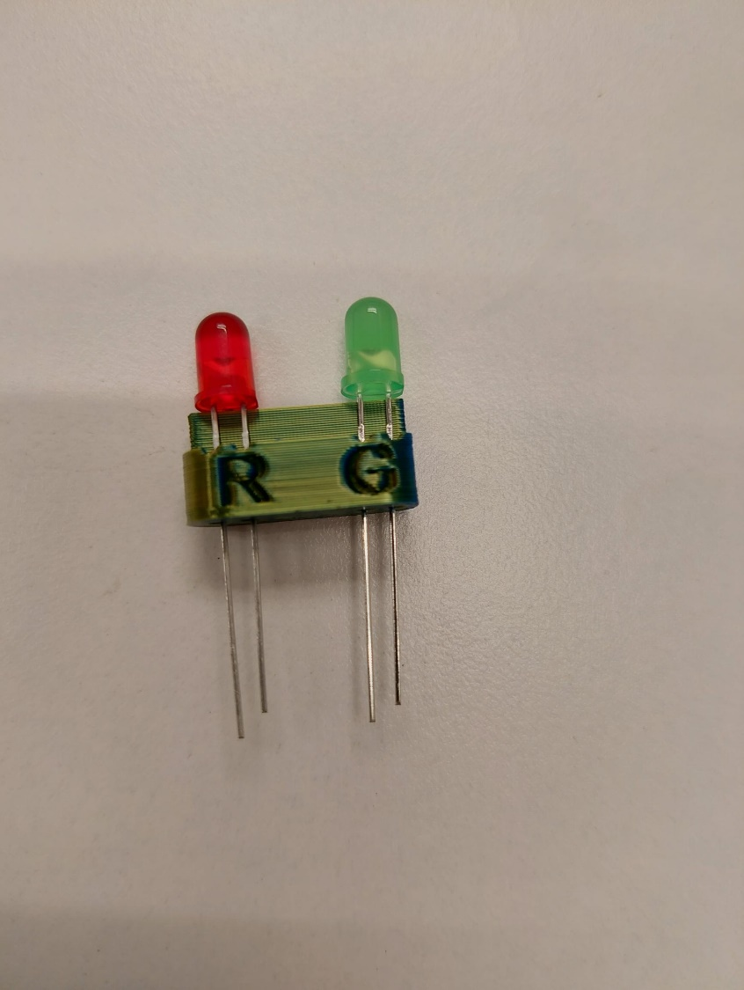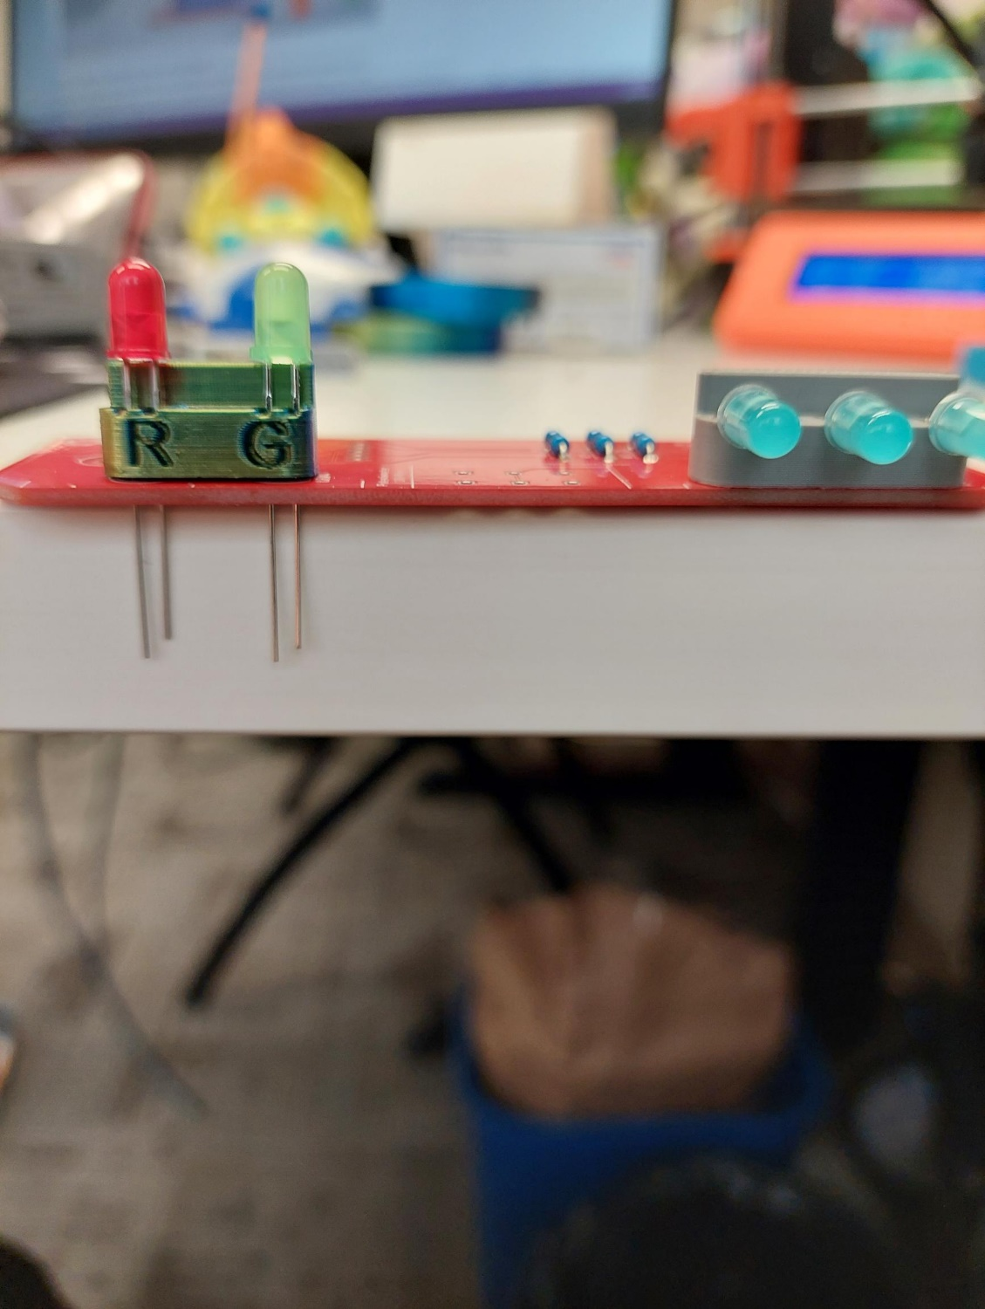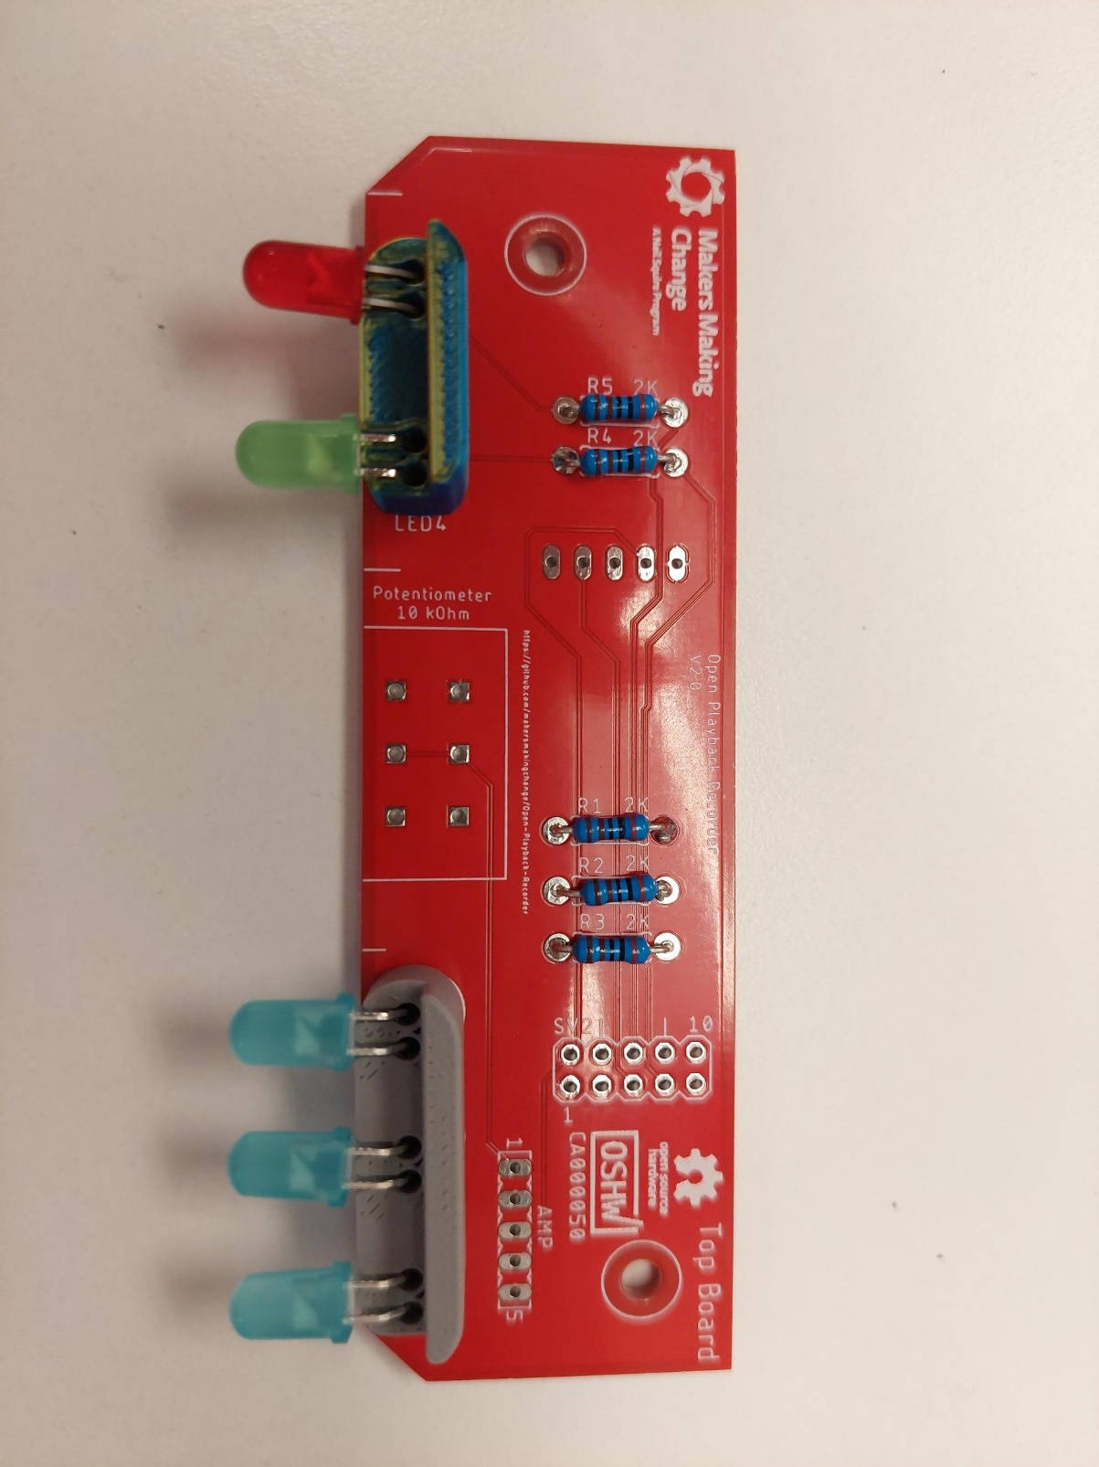

### Step 4: Solder the amplifier terminal and male headers

Take the amplifier (25) and solder the male headers onto it with the short side of the headers in the board, and the long pins facing away from the board, on the side with no electronic components. You may need to trim one pin off the headers that come with the board to make them fit. Take the screw terminal blocks that came with it, and solder them to the bottom of the board with no electronic components, with the connectors facing away from the pins, as shown in the photo.

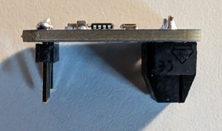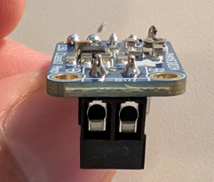

### Step 5: Solder the amplifier female headers

Take the 5 pin female header (26), and solder it to the AMP footprint on the PCB.

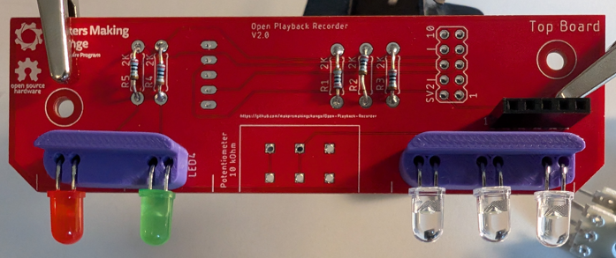

### Step 6: Solder the ribbon cable header onto the PCB

Take the ribbon cable header (10) and solder it to the SV2 footprint, aligning it so that the cutout on the header lines up with the two lines beside the text that says SV2.

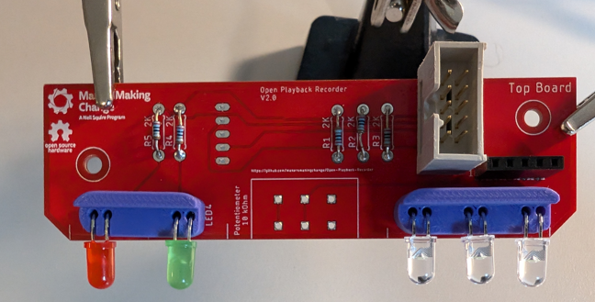

### Step 7: Solder the microphone to the PCB

Take the microphone (27) and solder it to the bottom of the PCB, aligning it so that the round microphone component on the board is roughly in the middle of the PCB. The short end of the headers should be going through the microphone and the long end through the PCB

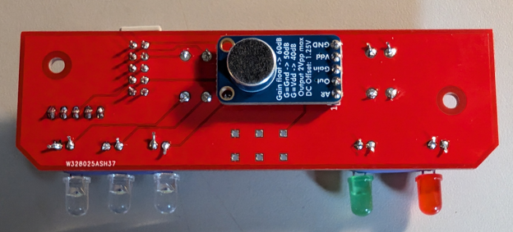

### Step 8: Solder the potentiometer into the PCB

Take the potentiometer (28) and solder it to the footprint labeled 10k Ohm so that the arm of the potentiometer is sticking out away from the board.

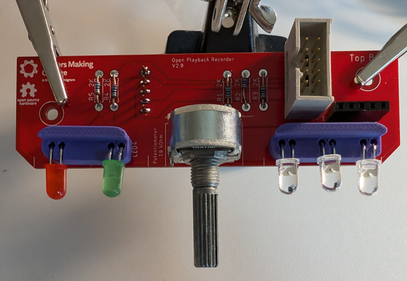

### Step 9: Slide the PCB into the top enclosure

Place the assembled PCB into the top enclosure (29) and slide it forwards so that the arm of the potentiometer passes through the hole labeled volume, and the LEDs all slide into their respective holes in the enclosure. Use two screws (11) to secure the PCB in place.

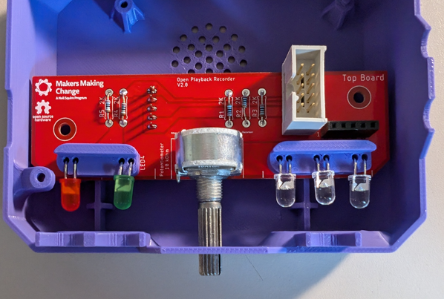

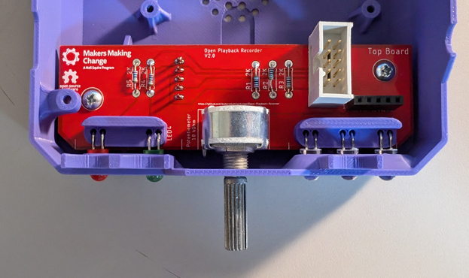

### Step 10: Attach the volume knob

Take the volume knob (30) and slide it onto the arm of the potentiometer.

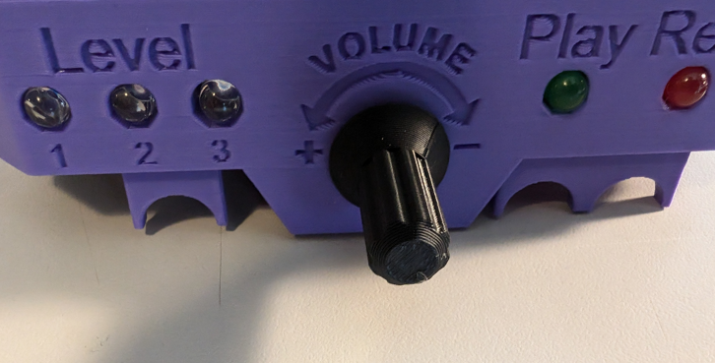

### Step 11: Prep the Speaker Wires

Take the speaker (31) and cut the lead to roughly 4 to 5 inches long. Strip 0.5cm off the ends of the wires, twist the wires together and use a bit of solder to tin them and make them solid.

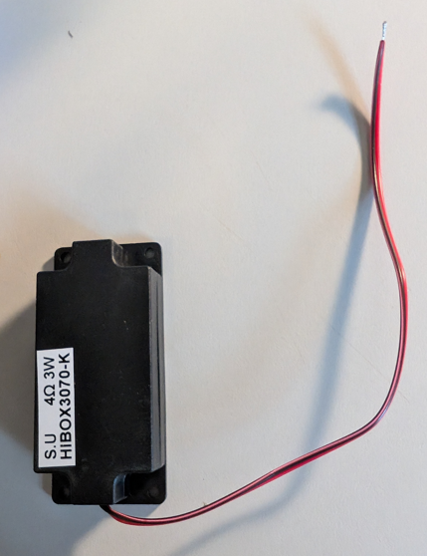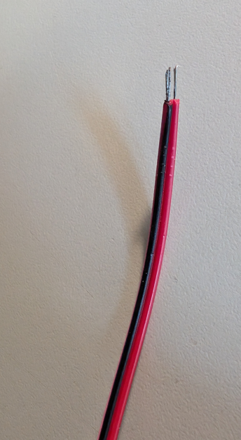

### Step 12: Screw the Speaker to the Enclosure

Screw the speaker onto the 4 posts in the enclosure, with the centre of the speaker over the grill in the enclosure.

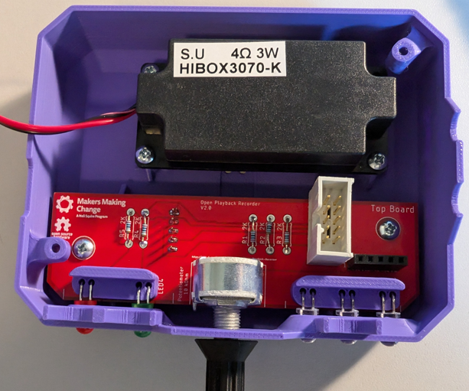

### Step 12: Connect the speaker

Take the stripped ends of the speaker wire, and screw them into the terminal blocks on the amp using the small flathead screwdriver. Plug in the amplifier to the 5 pin header on the PCB with the terminal block facing away from the LEDs.

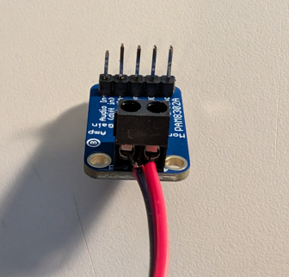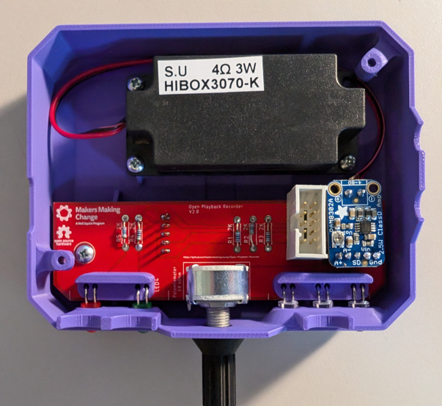

### Step 13: Connect the ribbon cable

Plug the ribbon cable (32) into the headers on both the top and bottom PCBs. The tab on the ribbon cable is on different sides on each end of the header, on the bottom PCB, the cable should be facing away from the microcontroller after being plugged into the header.

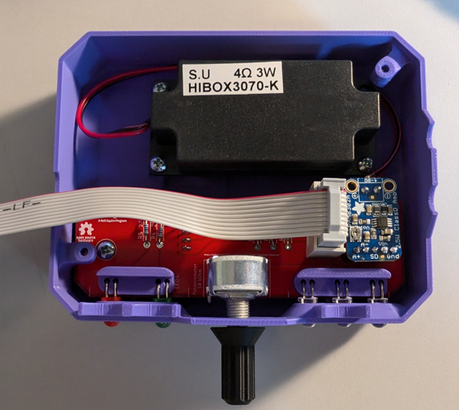

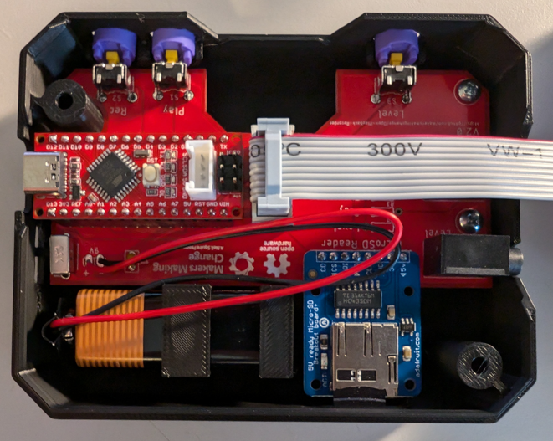

### Step 14: Close the enclosure

Close the two halves of the enclosure and secure it with 2 screws (11).

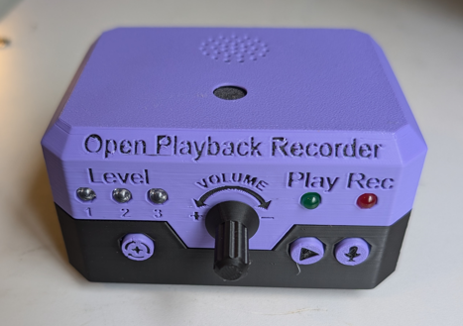

### Top Enclosure Done

# Programming

## Step 1: Setup Arduino IDE on Computer

1. Download Arduino IDE for your operating system at <https://www.arduino.cc/en/software>
2. Install the Arduino IDE.

## Step 2: Download the Firmware files

Download the firmware files from the GitHub Repository. Extract the folder to a known location and open the file in the Arduino IDE.

<https://github.com/makersmakingchange/Open-Playback-Recorder/blob/main/Build_Files/Firmware_Files/Open_Playback_Recorder_Firmware.zip>

## Step 3: Open the Library Manager

Click on the Tools menu, and select Manage Libraries. Alternatively, the menu can be opened with Ctrl+Shift+I

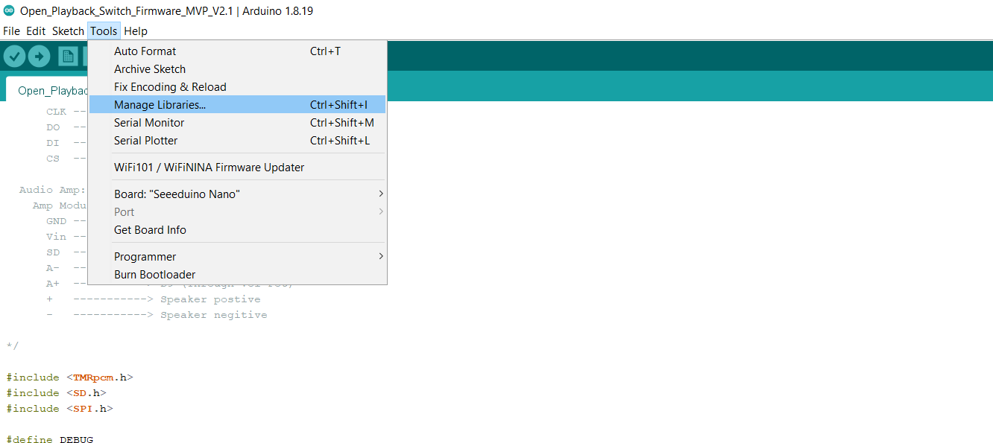

## Step 4: Search the TMRpcm library

Using the search bar on the top right of the menu, search TMRpcm. Install the library by TMRh20

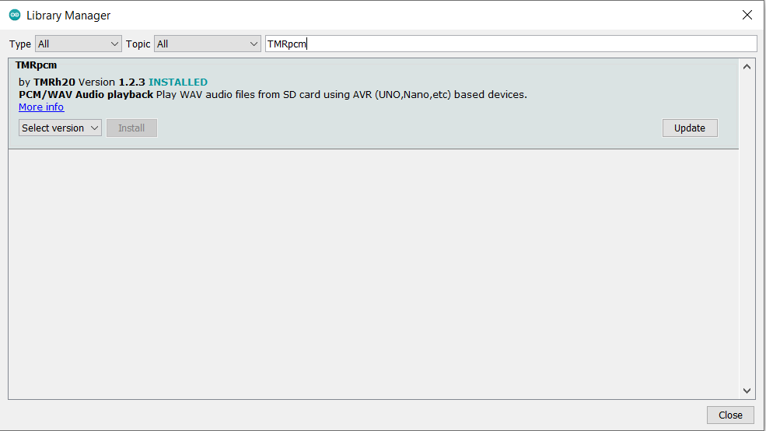

## Step 5: Enable Recording

Find the folder where the TMRpcm library was installed. This is usually in C:\Users\[NAME]\sketchbook\libraries\TMRpcm. Open the file pcmConfig.h in notepad or a similar text editor.

Uncomment the line “#define buffSize 128” by removing the “//” before #define buffSize128

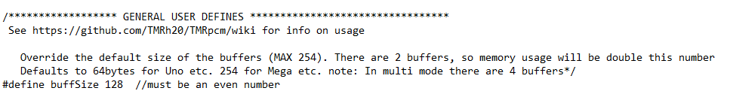

Uncomment the line “#define ENABLE_RECORDING” by removing the “//” before #define ENABLE_RECORDING

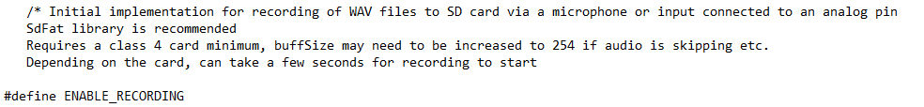

Save the file and close it.

## Step 6: Open the Preferences

Click on the File menu, and select Preferences. Alternatively, the menu can be opened with Ctrl+Comma.

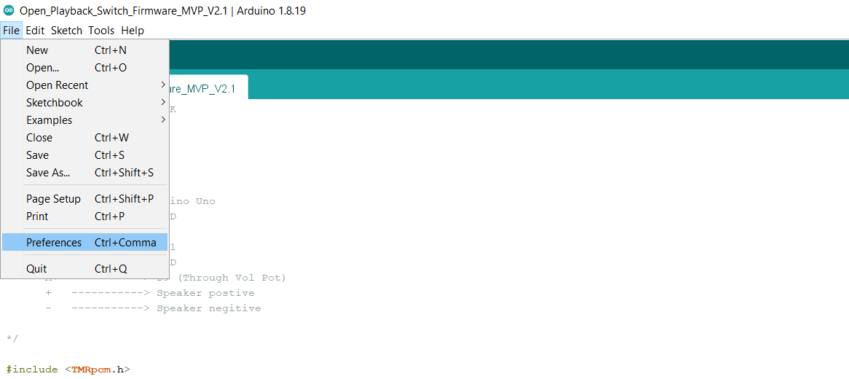

## Step 7: Add the Board URL

Copy the following link into the Additional Board Managers URL and hit ‘OK’

<https://raw.githubusercontent.com/Seeed-Studio/Seeed_Platform/master/package_legacy_seeeduino_boards_index.json>

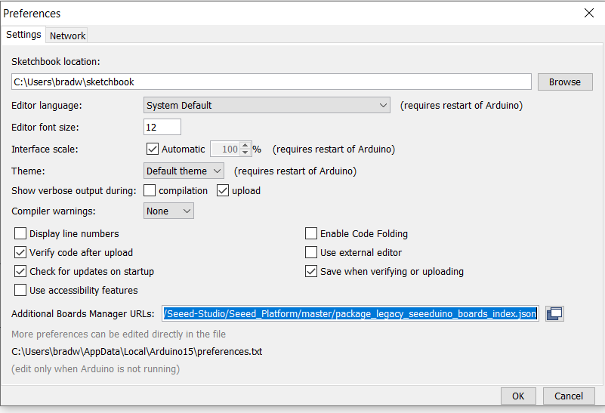

## Step 8: Add the Seeeduino Nano Board

Open the Board Manager from Tools > Board > Board Manager

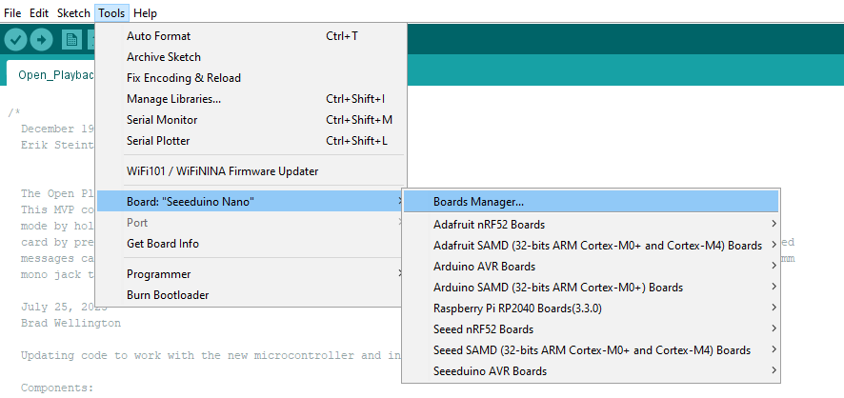

Type Seeeduino AVR into the search bar, and install the board package.

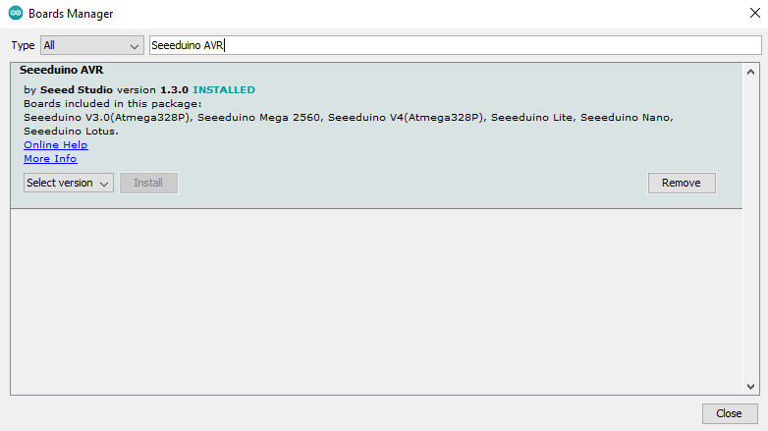

## Step 9: Connect the Open Playback Recorder to the Computer

Plug the microcontroller into the computer using a USB cable

## Step 10: Program the Microcontroller

In the Tools menu, set the board to Seeeduino Nano, and set the port to whatever port shows up when the microcontroller is plugged into the computer. After this, press the arrow button below the Edit menu to compile the code and upload it to the microcontroller.

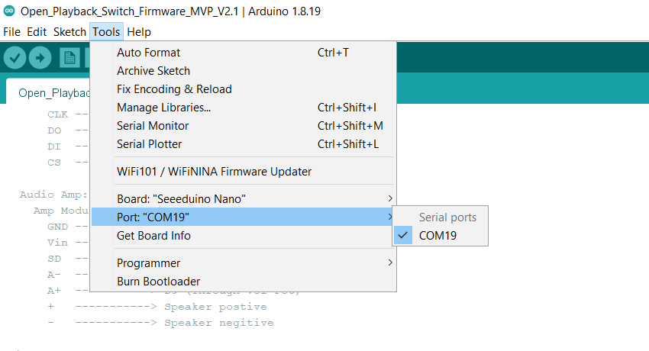

# Testing

Before delivering the device to the user, there are a series of tests to perform to verify that the device is working correctly.

## Power on the device with battery power

Flip the slide switch on the side of the device from off to on. The Level 1 LED should illuminate. If the Rec and Play LEDs are flashing instead, this means that there has been an issue initializing the MicroSD card.

## Record multiple messages on one level

Hold down the record button until the record LED turns on. This indicates that the device has entered record mode. At this point, holding either the play button or an assistive switch connected to the play jack will cause the device to record a message. The device will continue recording as long as the button is held down, and will finish the message when it is released. Record multiple messages, then press the record button again to exit record mode.

Pressing the play button will play the first message, and pressing it again will play the next message. Cycle through playing all the messages that were recorded until the first message is reached again.

## Adjust the volume

Using the volume control knob on the front of the device, change the volume while a message is playing to ensure that the volume changes as the knob is spun.

## Record a message on each level

Press either the level button, or an assistive switch connected to the level jack. The first level LED should turn off, and the second level LED should turn on. Record another message on this level, and repeat the process on the third level. Go to each level again and play back each message.

## Delete the multiple messages and record one message

Return to the first level where multiple messages were recorded and enter record mode again. Record a single message and play it back. All the previous messages should be deleted, and just the single message should play, no matter how many times the play button is pressed.

## Power the device with USB power

Flip the slide switch on the side of the device from on to off. Using a USB cable, plug the device into a computer or power block to provide power to the device. The device should power on the same as when it is on battery power, and should function the same as well.

# Troubleshooting

### Both Play and Record LEDs flashing when device is powered on

This indicates that the SD card has not been properly initialized. Try reformatting the SD card, if this does not work, check the soldering on the SD card reader and the microcontroller. Finally, if neither of the previous steps work, try a new SD card.